There are many different things you could do or say to reach out to people. You always have an ADVANTAGE when you approach people who KNOW you, LIKE you, and TRUST you, so this is a great place to start after you have LAUNCHED publicly on social media i.e., your Facebook timeline etc.
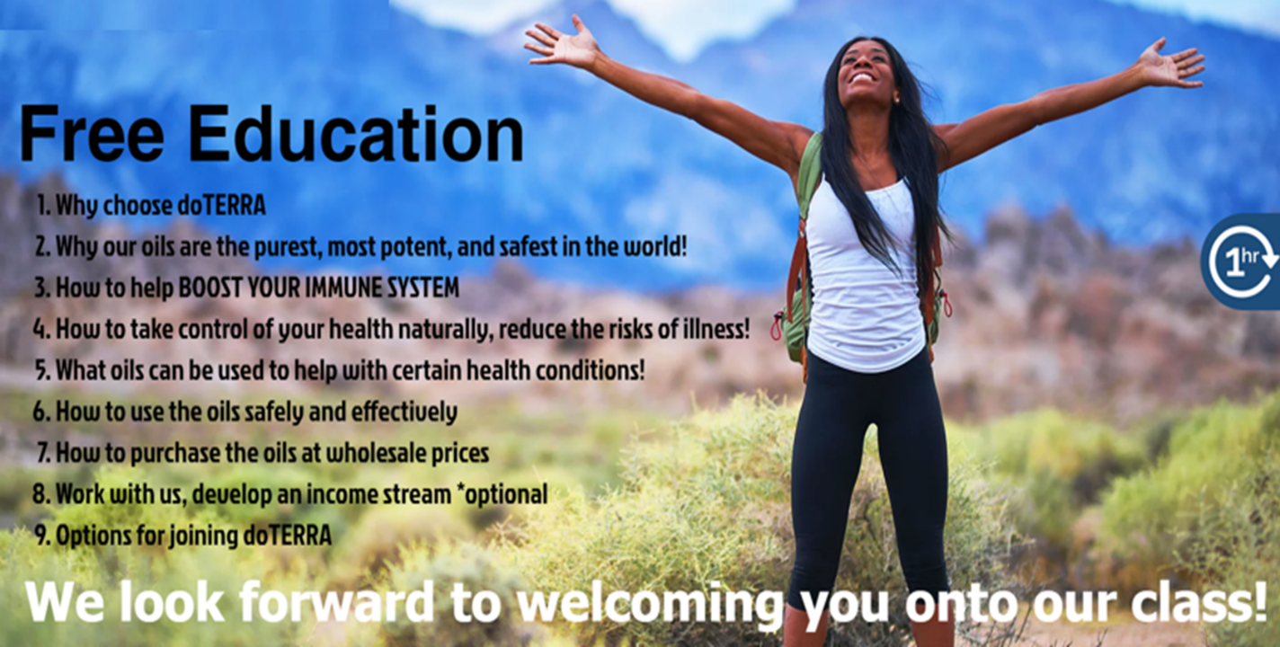
Remember the objective is ALWAYS to invite them onto an ‘Intro to Essential Oils Class’ where we provide FREE Education about our beautiful oils. Your sponsor will help and support you with this.

***Please note these messages contained in this document are to provide you with a basic guide to help you, please feel free to edit and make them your own***

A Private Message you could send to people you know.

Hi, I’m excited to tell you about something I think you’ll be interested in 😍
I’ve just partnered with the Global Leading Essential Oils company doTERRA, their oils are the purest and most potent essential oils in the world, certified 100% pure. They provide a natural alternative to using over the counter drugs and medication to support many common health issues that we can all relate to!
Have a look at this 4-minute video which explains it far better than me 😍
Natures Alternative: https://youtu.be/N4Xrj0aEp00
We are also looking for people who would like to earn a second income working spare time from home as a‘Product Consultant/Wellness Advocate’ the Earning Potential is AMAZING!
Have a look at this 2-minute Promo Video about the opportunity! https://youtu.be/X3hskxcUZxo

let me know if you would like some more info….

Write down everyone you message, and if you don’t hear back from them in a few days just send them a friendly reminder. People live busy lives as you know.

If they express some interest, or start asking you questions, try and resist getting into swapping messages back and forward with them this is not effective! Remember the best way to interest someone in doTERRA is for them to attend the ‘Intro to Essential Oils Class’ please do not forget this is how you joined, the class has the greatest impact on people, so this is YOUR OBJECTIVE, get them on a class!
Ask them to have a look at some extra info about our LIVE class we run every day for people who would like to find out more… this will make it easier for you to get them to attend.
We run these classes every day of the week, speak to your sponsor about the different times, they will support you when you have someone who wants to book onto a class.
Here is the site you can send them to help grease the tracks! www.whyouroils.com
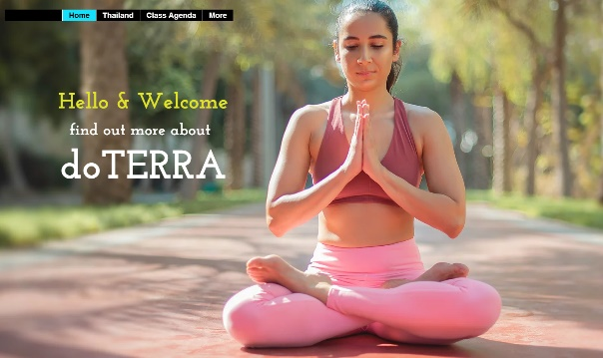

Again, you may need to chase them up, and then get them onto one of the classes! Let your sponsor know, they will help you with this.

If you are a Holistic Therapist and have an active client base!

If you are a Therapist, this is a great way to approach your existing to introduce doTERRA to add more value to your existing offering!

Hello Everyone. We are really excited to announce a fantastic NEW service available to you as valued customer of [ ] please read on..
Due to the growing concerns about the use of prescription drugs and over the counter medications because of: side-effects - dependencies - the long term ill effects these chemicals can have within our bodies, more and more people are turning to Natural Health Solutions.
We have therefore partnered with doTERRA , the world’s leading company in Sourcing, Testing, Manufacturing and Distribution of Certified Pure Therapeutic Grade essential Oils (CPTG)
These oils are not to be confused with “fragrance essential oils that just smell nice, they are 100% pure and free from artificial ingredients, fillers, synthetics - pesticides etc.
They are the purest and most effective essential oils in the world. These oils provide a very safe – natural and effective alternative to using over the counter drugs and medication to help people take control of their health naturally.
If you are interested in seeing the health benefits of using our essential oils, I would like to INVITE you to attend a FREE educational 1 hr online class to find out more!
Here is a 4 minute video that explains about the healing benefits of these amazing oils:
Natural Medicine: https://youtu.be/N4Xrj0aEp00
Validation that we produce the purest essential oils in the world: https://youtu.be/9sF_VPfYIMo
If you would like to find out more, please jest reply to this email; FIND OUT MORE/ATTEND CLASS
Thank you.

If someone asks you for a sample on social media:
Hi .... Great to hear from you, delighted to be able to help. Drop me back your full address and then let’s arrange a quick chat and I will get something off for you in the post. Peter x
Ps meanwhile have a quick look at this 4-minute video: What are 'Essential Oils' and why do they work so well: https://youtu.be/N4Xrj0aEp00

------------------------
***Please note the messages contained in this document is a guide to help you, please feel free to edit and make it your own***

If you really are serious about earning an Income in excess of £500-£1000 plus per month ( Sterling) Ideally you want to be looking for people who want more than just the oils, so people who may be interested in earning an income/developing a business with doTERRA.

